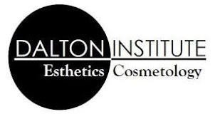
Dalton Institute is proud to present the opportunity for students to receive a $5000 Scholarship to be used at our school toward either the Esthetics or Master Cosmetology program. One student will be given the scholarship from each high school in the Dalton area.
Students participating in the chance to receive the scholarship will need to submit the following:
1.A 500-word essay about why they would like a career in the Esthetics or Cosmetology field and why they would like to attend our school.
2.School attendance report
3.A letter or recommendation from a teacher
Students should include contact information including phone number and email address.
We look forward to hearing from you and your students and reading their submissions. The deadline to submit is February 21, 2018. Recipients will be notified March 21, 2018. The scholarship is non-transferable and valid for approved recipient only.

Thank you for your participation.
Donna Baker – Marketing Coordinator

