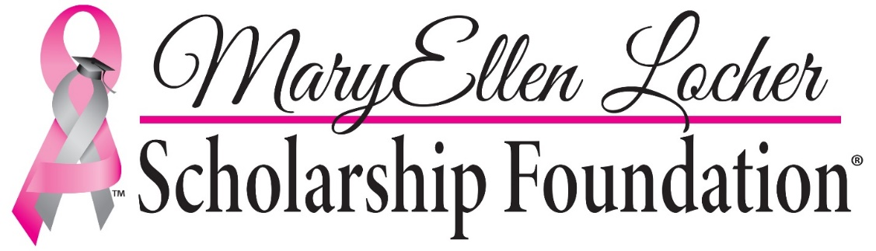

Scholarship Information 2021-22

Overview

The MaryEllen Locher Scholarship Foundation was established in 2002 by MaryEllen Locher, a news anchor and television personality from Chattanooga, Tennessee. The mother of a teen-aged son, MaryEllen passed away from breast cancer in 2005. Concerned over her own child’s future education, prior to her passing, she established a foundation to provide scholarships for undergraduate students. The scholarships are given to students who have lost a parent to breast cancer, children of breast cancer survivors, and children whose parents are still currently in treatment.

According to the terms of this scholarship, students will be selected on the basis of eligibility and their overall applications. The applications include, among other things, essays, references, transcripts, and recommendations. Applications, after being determined that the Applicant him/herself is eligible for a potential award, are sent to various readers on the Scholarship Committee. All applications are evaluated by at least three (3) readers (some years, depending on the number of applicants, they may be read by as many as six (6) readers). The MaryEllen Locher Scholarship Foundation Board of Directors will select winners after all applications have been evaluated.

The MaryEllen Locher Scholarship Foundation is a federally approved 501(c)(3) non-profit organization. The MaryEllen Locher Scholarship Foundation shows no bias toward students of any particular race, religion, or gender. None of these will be considered in awarding scholarships.

SCHOLARSHIPS ARE AWARDED FOR ONE ACADEMIC YEAR ONLY. EACH RECIPIENT MUST REAPPLY EVERY YEAR AND COMPLETE A NEW APPLICATION FORM. THERE IS NO GUARANTEE THAT PREVIOUS WINNERS WILL BE SELECTED AGAIN. IF SELECTED, YOUR FINANCIAL AWARD MAY CHANGE BASED ON YOUR EVALUATION, NUMBER OF APPLICANTS, AND THE AMOUNT OF MONEY AVAILABLE FOR SCHOLARSHIPS.

Due to the high volume of applicants, we cannot notify each individual student of our decisions. Winners will be notified personally by phone after April 1, 2021. Checks are paid directly to the winner’s college or university. No checks will be issued to a student personally.

Eligibility

Students applying for scholarships from the MaryEllen Locher Scholarship Foundation must meet the following criteria:

- Student must have lost a parent to breast cancer or complications relating from the disease OR have a parent who has survived breast cancer or is currently undergoing treatment for breast cancer.

- STUDENT MUST LIVE WITHIN A 50-MILE RADIUS OF CHATTANOOGA, TENNESSEE.

- Student must be a current high school senior who will graduate the year of application, a current college student, or have earned a GED.

- We do not set a minimum GPA requirement. Any student is encouraged to apply. However, GPA may be used as a factor in awarding scholarships.

- Student must be a legal resident of the United States.

- Student must be less than twenty-five (25) years old.

- Student must be accepted as a full-time enrollee in an undergraduate program at either a two (2) or four (4) year accredited college or university. The MaryEllen Locher Scholarship Foundation is not authorized to provide scholarships for graduate programs. We will only provide funding for four (4) years of undergraduate study.

Required Documentation

ALL APPLICATIONS, WHETHER MAILED OR HAND DELIVERED, MUST BE RECEIVED BY OUR OFFICE PRIOR TO THE CLOSE OF BUSINESS ON FRIDAY, JAN. 15, 2021.

- Please complete one entire application. Incomplete applications will not be accepted.

- Please provide ONE official copy of your school transcript, sealed and signed by a school official across the envelope seal (may be sent to us separately by school per school policy). NOTE: If you are a current COLLEGE student applying for a scholarship, we need your most recent college transcript. Please do not send a high school transcript if you are currently enrolled in college.

- At least ONE letter of recommendation must be included. It must be in a sealed envelope with the writer’s signature across the envelope seal (may be sent to us separately by the writer him/herself). We encourage you to seek recommendation letters from teachers, counselors, coaches, ministers, civic/community leaders, or employers, rather than family members. We recommend that you personalize your letter to our scholarship, rather than submit a “generic” letter.

- Official documentation of your parent’s cancer must be included. This could include a note from a doctor, diagnosis documents, or a death certificate. Personal medical information will always be kept confidential.

- Please include your “resume,” including your extracurricular activities, sports and leadership positions, church/community involvement, employment, and awards.

- Please e-mail at least one photo of yourself to cindy@melfoundation.org. Photos could be senior portrait-type shots. We would also like a photo of yourself with your parent who was affected by breast cancer, if possible. (Photos that are e-mailed are easier to transfer to our website and Facebook page. Please send in JPEG format. Thanks for your cooperation.)

Student Essays

THREE (3) individual, typewritten essays are required for each applicant. Please include your name and address on the front page of each essay.

Essays should be typed, double spaced, in Times New Roman (or another similar font), with each essay beginning on a new separate page. They must have the topic title at the beginning of each essay. Essays should be a minimum of five paragraphs. Please use spellcheck and proofread your essays for correct spelling, grammar, and punctuation.

Essay #1 – This is required for all applicants:

What is your story? Why are you applying for the MaryEllen Locher Scholarship?

(We are aware that this is a very open-ended topic, but we want to get to know you, your parent that has had breast cancer, and your family. Some examples of what other applicants have mentioned throughout their essays: Who was/is your parent that has battled cancer? Tell us their story, from your perspective. What do you plan to do with the scholarship, if awarded? Why do you deserve this scholarship?)

Essay #2 and #3 – Choose from any of the topics below:

- What advice would you give to a child whose parent has just been diagnosed with breast cancer?

- How will receiving this scholarship affect you and your family?

- How has the occurrence of cancer in your parent impacted your life?

- What was the biggest adjustment in your life since your parent’s battle with cancer began/ended?

- If your parent is deceased, how have you and your family honored and carried on the memory and legacy of your parent?

- What have you learned from this experience and how might you help others because of it?

- What do you prize more now than before this experience?

Submission of Application Process

You can submit your application via United States mail or hand delivery. PLEASE SUBMIT TEN (10) COPIES OF APPLICATION FORM, ESSAYS, EXTRACURRICULAR ACTIVITIES, AND RECOMMENDATION LETTERS. Only ONE copy of your transcript and medical proof of diagnosis is needed. It is your responsibility to ensure you have submitted, and that the MaryEllen Locher Scholarship Foundation has received, all required documentation. The MaryEllen Locher Scholarship Foundation has no responsibility to notify any applicant if their application is incomplete.

United States Mail Submission:

If you choose to submit your application via United States mail, please mail your application, in its entirety, to:

Cindy Pare
MaryEllen Locher Scholarship Foundation
P.O. Box 4032
Chattanooga, TN 37405

NOTE: We highly recommend sending by certified mail to guarantee delivery. PLEASE RETAIN A PERSONAL COPY OF ALL DOCUMENTS IN CASE OF ANY ISSUES WITH MAILING.

Hand-Delivery Submission:

If you choose to submit your application via hand delivery, please contact our office prior to coming by to ensure that someone will be available. Our location is:

MaryEllen Locher Scholarship Foundation
2444 Broad Street
Chattanooga, TN 37408
Telephone: (423) 490-4555 E-mail: cindy@melfoundation.org

ALL APPLICATIONS, WHETHER MAILED OR HAND DELIVERED, MUST BE RECEIVED BY OUR OFFICE PRIOR TO THE CLOSE OF BUSINESS ON FRIDAY, JAN. 15, 2021.

